CMPS312 Project Phase 1 - YalaPay
Project Documentation and Testing Screenshots

Bsmalla Mostafa 202204404
Ahya AlWattar 202204901
Carmela Chavez 202206774
Ganna Soltan 202205763

Grading Rubric - In the Functionality column please specify either: Working (completed x%), Not Working (completed x%) or Not done.
Criteria |  | % | Functionality* | Quality of the implementation
- Application Design: Repositories or Providers Class Diagram |  | 5% | 100%
2) Design and implement |  | 90%
 | U1 – Login | 5 | 100%
 | U2 - YalaPay Dashboard | 5 | 100%
 | U3 - List/Search/Add/ Update and Delete a customer:  1. List Customers (5 pts)  2. Search Customers (4 pts)  3. Add Customer (6 pts)  4. Update Customer (4 pts)  5. Delete Customer (3 pts) | 22 | 100%
 | U4 - List/Search/Add/ Update and Delete an Invoice  1. List Invoices (5 pts)  2. Search Invoices (4 pts)  3. Add Invoice (6 pts)  4. Update Invoice (4 pts)  5. Delete Invoice (3 pts) | 22 | 100%
 | U5 - List/Search/Add/ Update and Delete payments for an invoice  1. List Payments (5 pts)  2. Search Payments (4 pts)  3. Add Payment (8 pts)  4. Update Payment (5 pts)  5. Delete Payment (3 pts) | 25 | 100%
 | U6 - Manage Cashing Cheques  1. Add Cheques Deposit (10 pts)  2. List Cheque Deposits (5 pts)  3. Update Cheques Deposit (15 pts) | 30 | 100%
 | U7 - Invoices Report | 8
 | U8 - Cheques Report | 8 | 100%
3) Testing documentation using screen shots illustrating the app testing.  - Discussion of the project contribution of each team member [-10pts if not done] |  | 5% | 100%
Total |  | 100
Copying and/or plagiarism or not being able to explain or answer questions about the implementation |  | -  100
* Possible grading for functionality - Working (get 70% of the assigned grade), Not working (lose 40% of assigned grade and Not done (get 0). The remaining grade is assigned to the quality of the implementation.
In case your implementation is not working then 40% of the grade will be lost and the remaining 60% will be determined based on of the code quality and how close your solution to the working implementation.
Solution quality also includes meaningful naming of identifiers (according to Flutter/Dart naming conventions), no redundant code, simple and efficient design, clean implementation without unnecessary files/code, use of comments where necessary, proper code formatting and indentation.
Marks will be reduced for code duplication, poor/inefficient coding practices, poor naming of identifiers, unclean/untidy submission, and unnecessary complex/poor user interface design.

Team Member Contribution
Bsmalla Mostafa
- Invoice Details Screen
- Invoice Add/ Update Screen
- Invoice Report Screen
- Invoices Screen
- Payment Details Screen
(And any associated widgets, routes and providers)

Ahya AlWattar
- Cheques Screen
- Cheque Deposit Details Screen
- Cheque Deposit Add Screen
- Cheque Deposit Update Screen
- Cheque Details Screen
(And any associated widgets, routes and providers)

Carmela Chavez
UI Layout of the Whole App
- Login Screen
- Dashboard Screen
- Cheque Image Screen
- Cheque Report
(And any associated widgets, routes and providers)

Ganna Soltan
- Shell Screen & shell navigation (initial router)
- Customers Screen
- Customer Details Screen
- Customer Add Update Screen
- Payment Add Update Screen
(And any associated widgets, routes and providers)

UI and Layout Design Sketches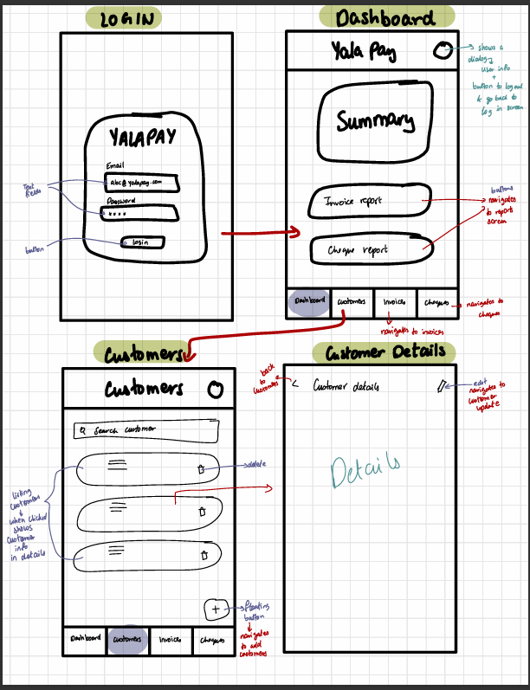

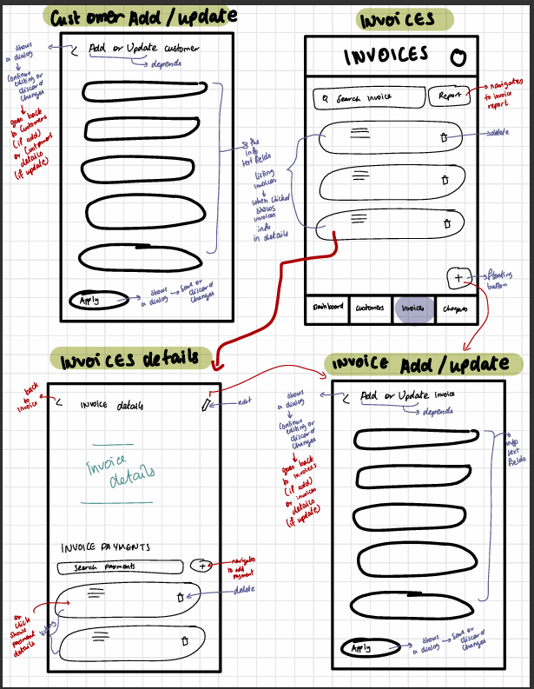

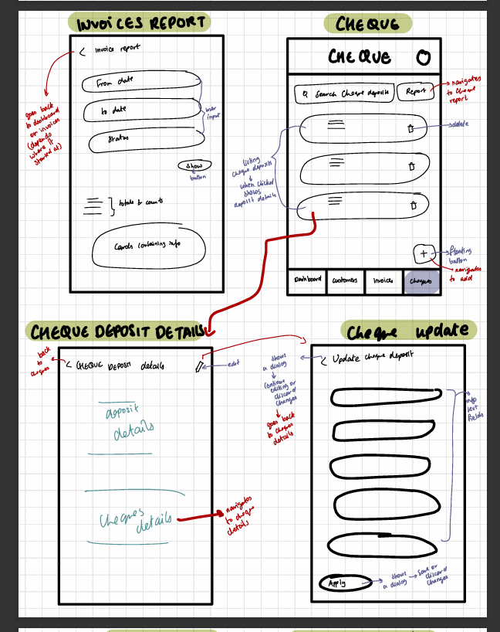

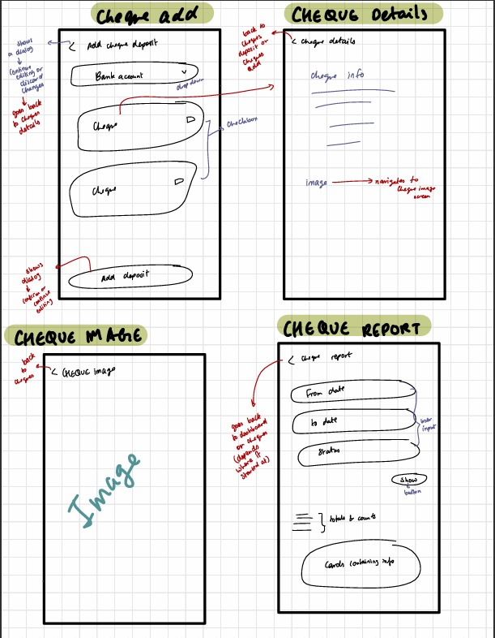

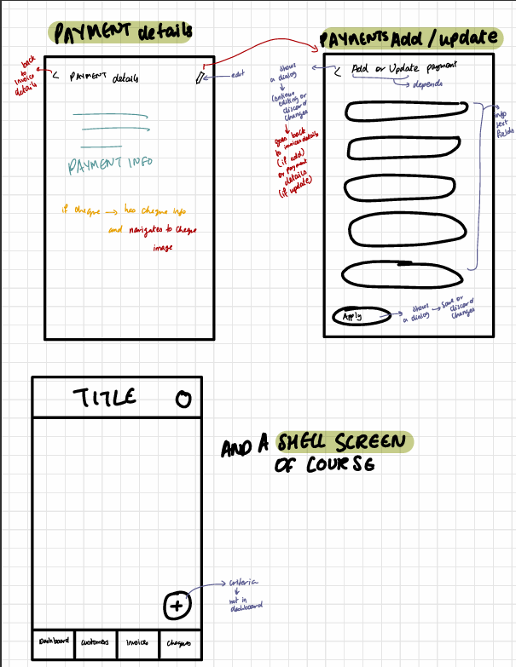

UI and Screen Testing Screenshots

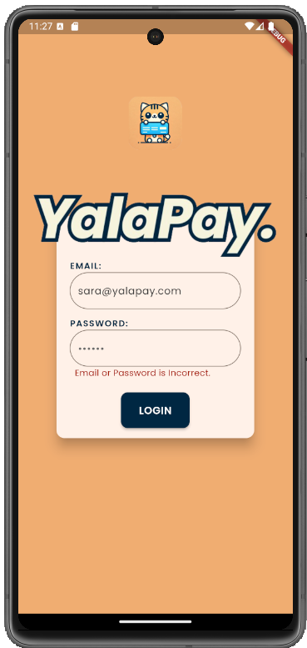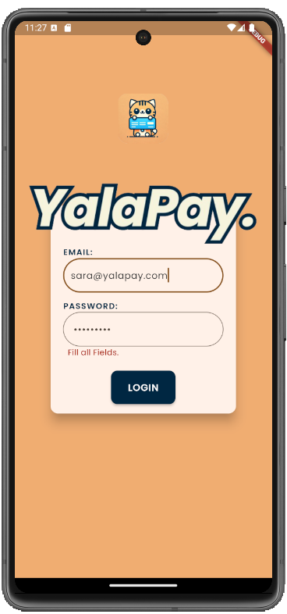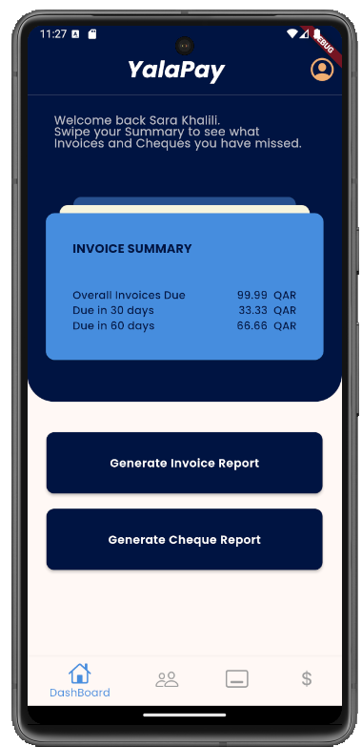

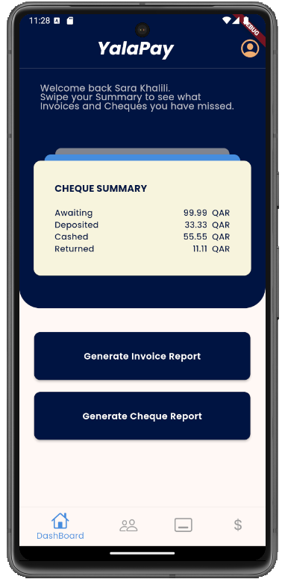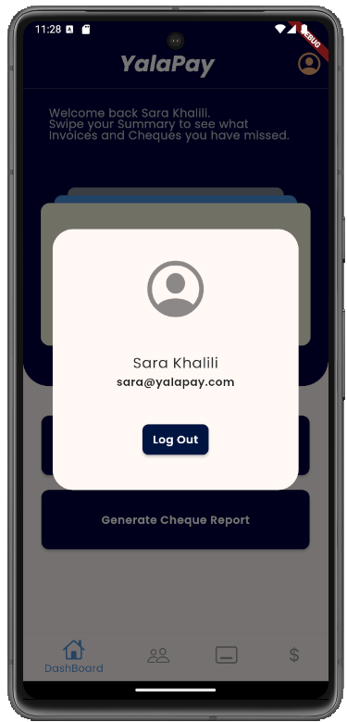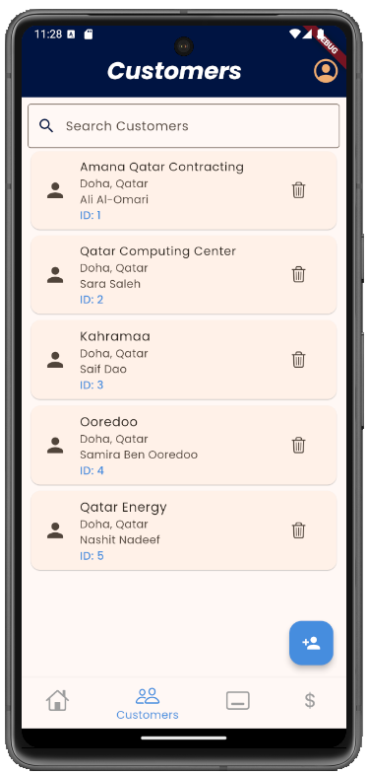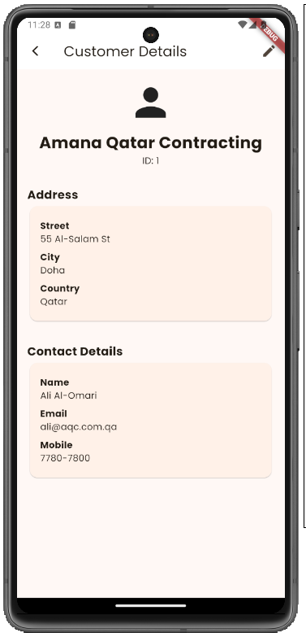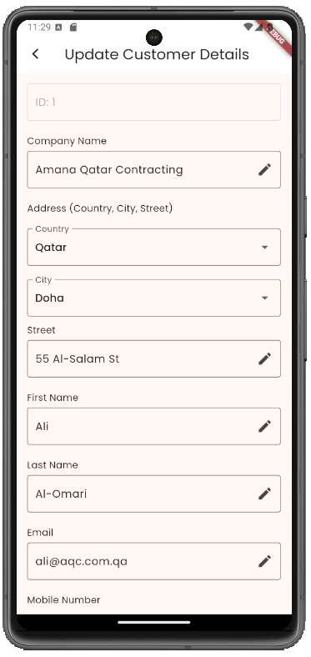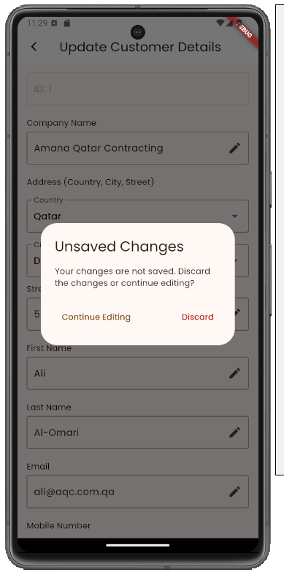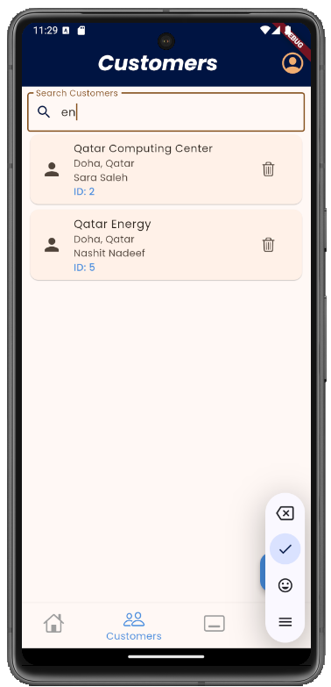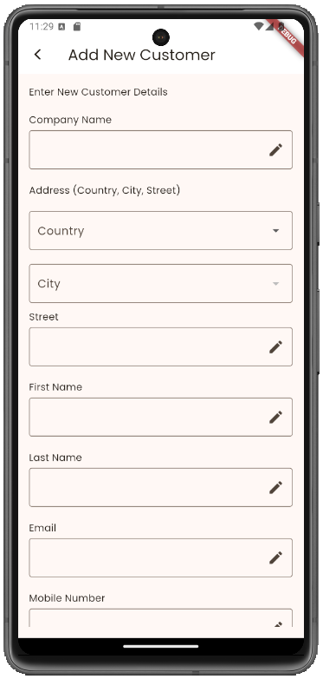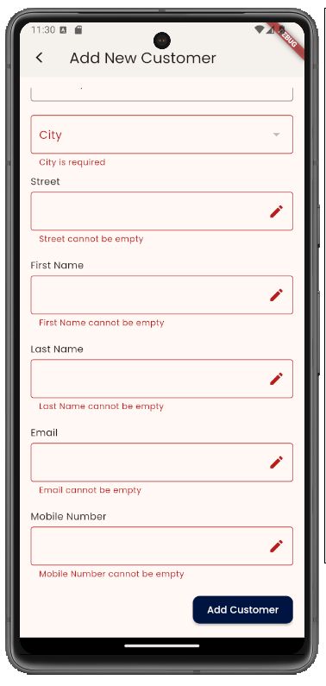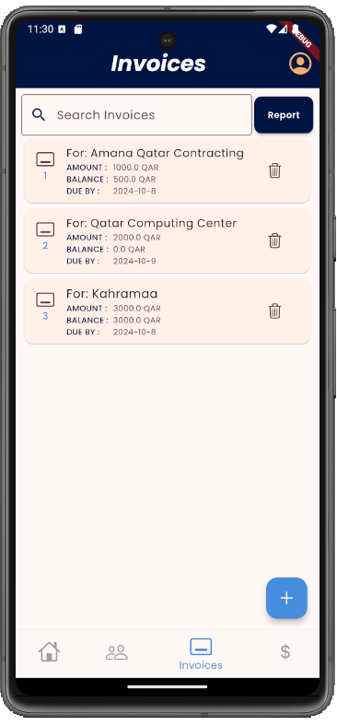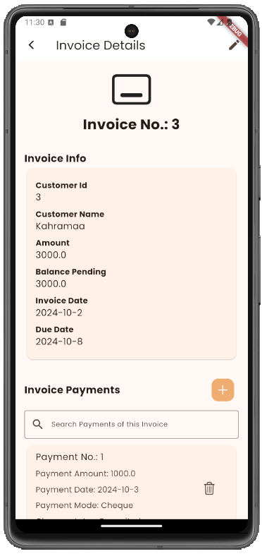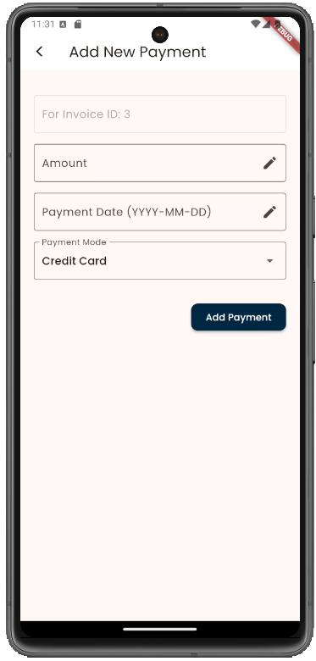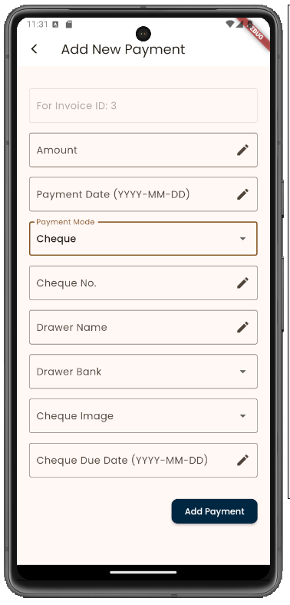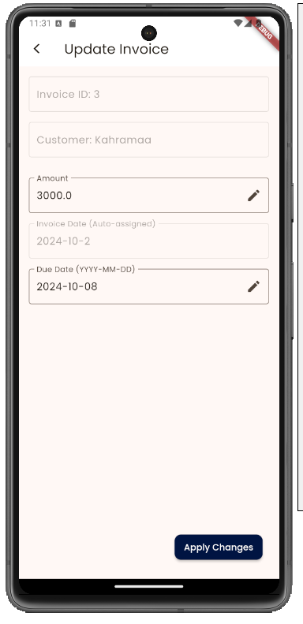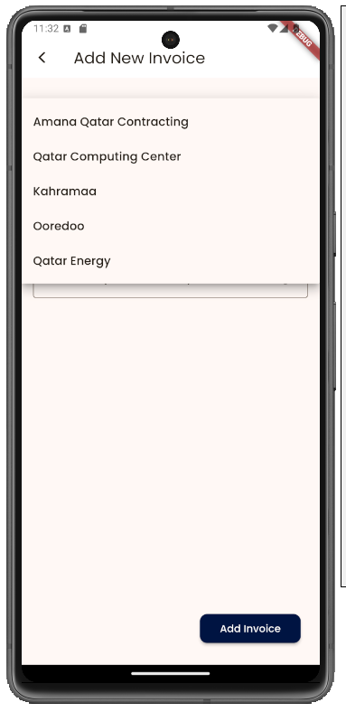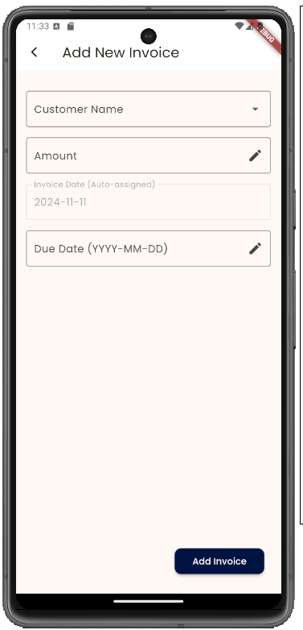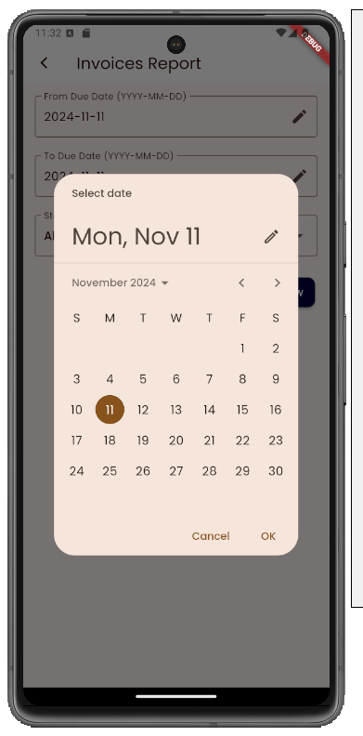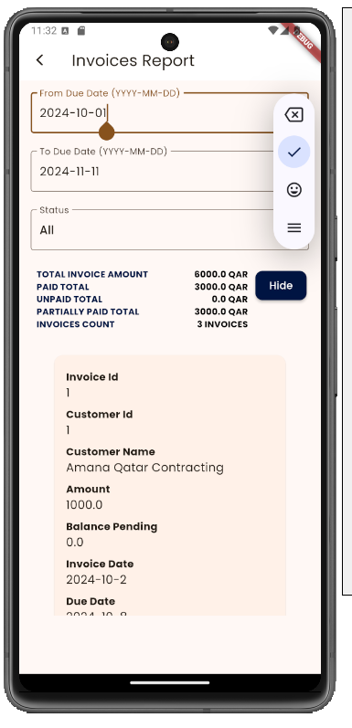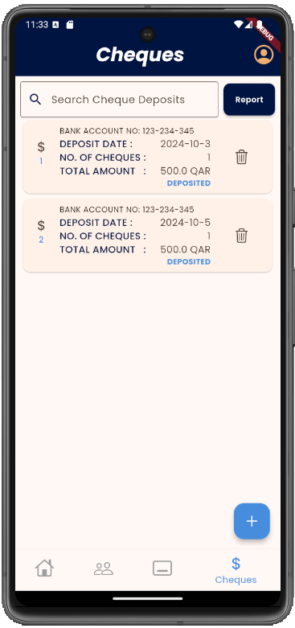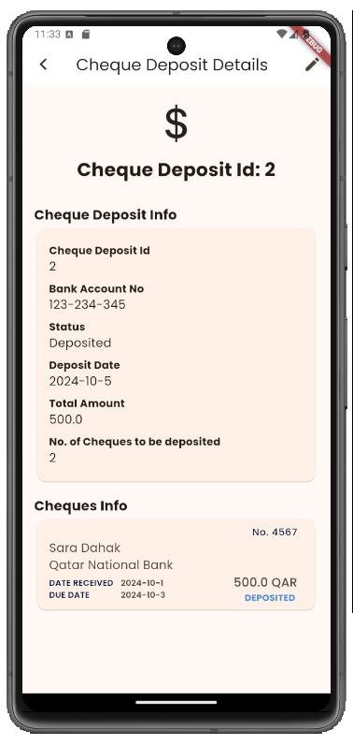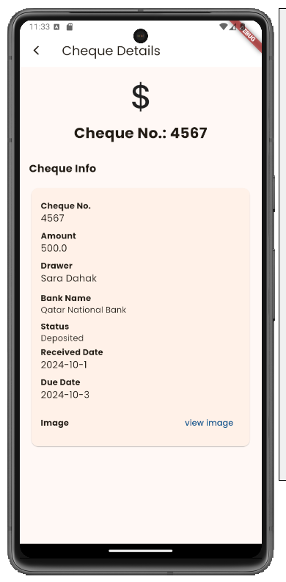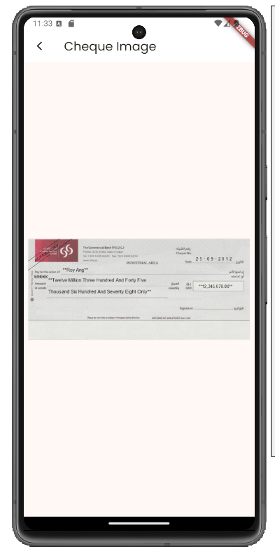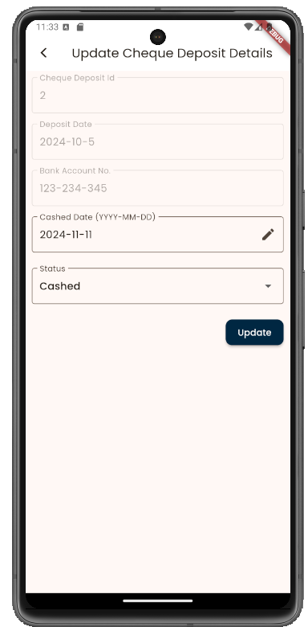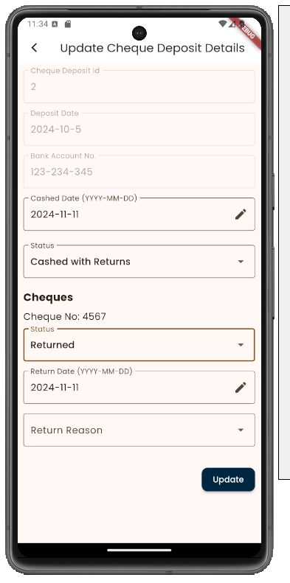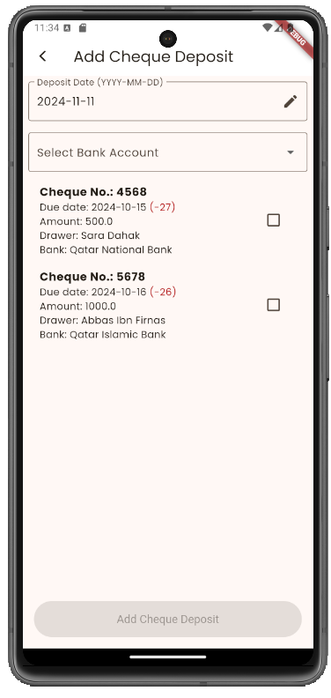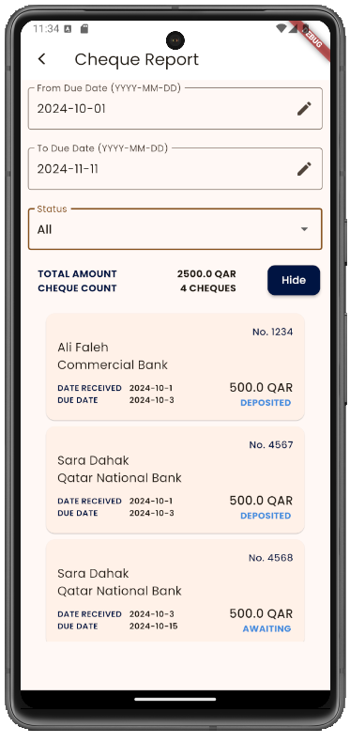

Class Diagram:
